

**Reservation Agreement**

**Reservation Code** : {{reservationCode}}

**Reservation Date** : {{date}}

**Seller Name** : {{sellerName}}

**Seller Mobile Number** : {{sellerMobileNumber}}

**BUYER DETAILS:**

Full Name : {{fullName}}

Birthdate : {{birthdate}}

Complete Address : {{address.city}}, {{address.province}}

ID Type : {{idType}}

ID Number : {{idNumber}}

Email Address : {{emailAddress}}

Mobile Number : {{mobileNumber}}

**PROPERTY DETAILS:**

Project Name : {{projectName}}

Location : {{location}}

Unit Type/House Model : {{unitType}}

Property Code : {{propertyCode}}

Block / Floor Number : {{block}}

Lot / Unit Number : {{lot}}

Floor Area : {{floorArea}}

Lot Area : {{lotArea}}

Bedrooms : {{bedrooms}}

Toilet & Bath : {{toiletAndBath}}

Floors : {{floors}}

Carports : {{carports}}

Property Map : *Attached as Annex “A”*

**PURCHASE DETAILS:**

Total Contract Price : {{totalContractPrice}}

VAT : {{vat}}

**PAYMENT DETAILS:**

Payment Date : {{paymentDate}}

Receipt No. : {{receiptNumber}}

Reservation Fee/Processing Fee : {{reservationFee}}

**CONSENT for RESERVATION AGREEMENT:**

I hereby attest that all the information disclosed in this **Reservation Agreement** and all related contracts are true and correct and agree to notify **Raemulan Lands, Inc.** through its managing company, **{{managingcompany}}** of any changes in the information contained herein.

I hereby acknowledge that I have read and understood the terms and conditions as well as the data privacy policy outlined by **Raemulan Lands, Inc.** at [**https://www.enclaves.ph/TCprivacyPolicy**](https://www.enclaves.ph/TCprivacyPolicy). By signing this document, I agree to abide by the terms and conditions set forth by the company and consent to the collection, processing, and usage of my personal data in accordance with the stated privacy policy.

**Buyer’s ID Mark:**



**ANNEX “A”**

**Property Map**

**Project Name** : {{projectName}}

**Location** : {{location}}

**Property Code**  : {{propertyCode}}

**Block / Floor Number** : {{block}}

**Lot / Unit Number** : {{lot}}

You may view the property map online at [https://keymap.enclaves.ph/{{productsku}}/{{propertyCode}}](https://keymap.enclaves.ph/%7B%7Bproductsku%7D%7D/%7B%7BpropertyCode%7D%7D).

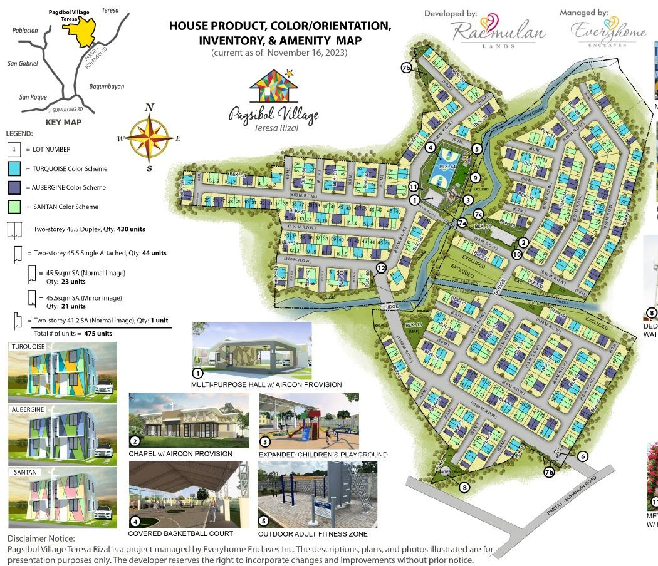

**Buyer’s ID Mark:**